ECOOL RESOURCES LTD.

CONTENTS

OVER VIEW
GENERAL INFORMATION OF THE ORGANIZATION
QUALITY STATEMENT
FLOW OF MANAGEMENT
OUR TECHNICAL EXPERTS
SERVICES WE OFFER:
- Evaporative Cooling system
- Evaporative air Cooler
- Ventilation exhaust fan.
- Evaporative Cooling pad
- Axial blower fan
- Cooling tower and its spare parts
- Fire Proof Door/ Emergency Exit Door
OUR SIGNIFICANT CLIENTS
List of tools

ECOOL RESOURCES LTD
House- 643(1st floor),Road-10,Avenue-03, DOHS Mirpur,
Dhaka. Bangladesh

Phone-880-1714092912
Email- info@ecoolbd.com
Web: www.ecoolbd.com
Facebook; www.facebook.com/ecoolbd

We are the pioneers of the evaporative cooling mechanisms for factory cooling in Bangladesh! It’s a simple technique which we have mastered and perfected and today we supply this machinery all over Bangladesh from all over the world. That is the smartness of our engineering – it’s simple, its effective and it’s also cost-effective!

We import machinery of the top quality from all over the world. Our product listing is already huge, but if you think you need something else, we will happily get it for you from any corner of the world. This dedication to our clients is what keeps us at the top of our game, and it’s also what keeps our customers so pleased with us.

We are proud to find ourselves amongst the top companies for employee satisfaction. We have an experienced support team offering round the clock customer care. We provide maintenance services and regular servicing options with reminders for part or machine replacement.

But the best part – we keep your factories cool so that you can work worry-free! Once you start doing business with us, all the responsibility is ours.

What We Do

Temperatures in high-friction, compact work places such as garments factories can easily exceed the healthy levels. This exposes the factories to excessive risk of overheating and fire, in addition to causing discomfort to the workers and harming the machinery. Product quality and worker productivity decreases. Such unwanted outcomes can be avoided by simply installing a proper cooling system. While air conditioning or refrigeration systems can be too expensive for factories, our evaporative cooling solutions have the advantage of being suitable for large spaces and they come at comparatively low prices! Using the simple technique of evaporation of water into the airstreams, our evaporative cooling machinery can reduce your factory temperature by up to 12 degrees.
We will personally visit your factory and determine which cooling method is most suitable for it. Our engineers will make all the necessary observations and design exactly what you need, specific to your factory’s individual requirements! You can just sit back and relax as our efficient installation team sets up the cooling apparatus within a matter of days of your order. Soon you will feel the cool breeze of our evaporative cooling tower in your factory and watch as worker productivity and product quality improves overnight!

Basic Information

Name: ECOOL RESOURCES LTD.
Address House-643(1st floor),Road-10,Avenue-03,Mirpur DOHS,
Dhaka. Bangladesh
Mobile 01714092912,
Email Address: info@ecoolbd.com, rana@ecoolbd.com
Web Address: www.ecoolbd.com
Year of Establishment 2007
Trade License No 02- 03963
VAT Registration No 17011049800
VAT Area Code 170101
Company TIN Number 897063238220/ Circle-183, Taxes Zone-09, Dhaka
Tin No of Director Masud Rana
Tin No. 748467729169/Taxes Circle-061, Taxes Zone-03, Dhaka
Bank Certificate:

Bank Name Jamuna Bank Limited
Account Title: Ecool Resources Ltd.
Current Account No 00010210013474
Branch Mohakhali

Bank Name Bank Alfalah
Account Title: Ecool Resources Ltd.
Current Account No 070801870055
Branch Mirpur

Facility of the Organization:
Office area 1100 square fit
Workshop area two, Each area 3600 square fit
Truck 2 nos (1000Kg each)

Flow of Management

Managing DirectorDirector
Advisor &Consultant
Management

Director (Commercial)
Director
(Admin & Accounts Account)

Project Management

Quality Management

Engineers Management

Labor Management

Director
(Project)

Director
(Finance)

Our Technical Experts:

ECOOL RESOURCES LTD’S EXECUTIVE AND Engineers are experienced in a wide range of project activities. Our employee stays abreast of the latest developments in the industry, allowing us to provide our clients with the most appropriate solutions to meet their needs.

Name of Employee | Field of Experience
Masud Rana  Managing Director  Founder of ECOOLRESOURCES LTD.  Email:rana@ecoolbd.com  Call:01714-092912 | 8 years professional experience in  A. Evaporative Cooling system Consultancy, Erection, Fabrication, Installation, Inspection, and Testing of cooling system.  B. Design, Drawing, Estimation of cooling and ventilation system.
Engr. Md. Anwar sadat Raju  Diploma Engr. (EEE)  GM  Email:info@ecoolbd.com  Call:01755567593 | 10 years professional experience in  A. Erection, Fabrication, Installation, Inspection, and Testing of Piping work at Garments and Textile.  B. Design, Drawing, Estimation of BTS ( Mobile technology)
Engr. Hafizur Rahman  B.SC Engr.  Manager  Email:info@ecoolbd.com  Call:01727064480 | 10 Years professional experience in  A.Erection, Fabrication, Installation, of Tank and Piping work at cooling system.  B. Erection, Fabrication, Installation, Inspection, and Testing, of Electrical and Instrumentation in textile and pharmaceutical
Engr. Sorup Halder  Diploma Engr. ( Electrical)  Asst. Manager  Sales and Marketing  Email:info@ecoolbd.com  Call:01727-064483 | 8 years professional experience in  A. Erection, Fabrication, Installation of Electrical System at Power plant and Textile Sector.
Md. Milon Sharif  Asst. Manager  Sales and Marketing  Email:info@ecoolbd.com | 6 years experience in sales and marketing in cooling and ventilation system.
Md. Sohel Rana  Sr. Executive Sales and marketing  Email:info@ecoolbd.com | 6 years professional experience in  Cooling system, ventilation system Marketing and in pharmaceutical and textile sector.
Engr. Ashis Biswas  Diploma Engr ( Electrical)  Sr. Sales and Marketing  Email:info@ecoolbd.com | 6 years professional experience in  A. Erection, Fabrication, Installation of Electrical System at Power plant and Textile Sector.

Quality Statement:

Ecool Resources Ltd. is the pioneers of the evaporative cooling mechanisms for factory cooling in Bangladesh . Ecool imports and distributes quality fans and ventilation products, Cooling tower, axial fan, fire exit door, industrial rack throughout Bangladesh.
To provide excellence in quality, service and customer satisfaction which are quality goals of our team are to
- Make client service our top priority.
- Ensure design quality through an attitude of prevention rather than detection
- Encourage continuous improvement of design through engineering development, automation and Improvement of project management processes.
- Provide well planned and through engineering designs proven technologies.
- Produce engineering documents which are clear, concise and professional.

Quality assurance starts with an attitude of prevention rather than detection because quality is defined by the client; quality assurance begins with an accurate assessment of your needs. We will start by listening to your needs and objectives for your project and we will design accordingly.

The needs assessment including –
- Return on Investment
- Budget
- Serviceability
- Sustainability
- Cost of Maintenance
- Cost of Operation
- Flexibility
- Reliability

SERVICES AND PRODUCTS:

We boast a vast range of products. Here are just some of them which you can explore. We will always cater to your specific needs and no amount of work is too much for us to get your factory the best cooling mechanism!

Evaporative Cooling and ventilation System

- Evaporative Cooling Systems
- Evaporative Air Cooler
- Evaporative Cooling Pad
- Industrial Exhaust Fan (All shapes and sizes)
- Roof-Mounted Exhaust Fan
- Wind Turbine
- Axial Blower Fan
- Centrifugal Blower Fan

In addition, for your convenience we also bring in products for your factory’s safety and utility!

Utility Products:

- Industrial Rack (All sizes)
- Textile Machinery
- Evaporative Cooling Tower and its parts

Evaporative cooling and ventilation system:

Ecool equipment and associated brands are recognized by leading mechanical consultants
throughout Bangladesh. In cooperation with consultants, project engineers and designers ecool can ensure the continued availability of economical, efficient and leading ventilation technology.

Service

- All kind of Support Structure Fabrication and Installation of cooling system.

- Erection, Fabrication and Installation of Evaporative air cooler.

- All types Duct Fabrication with Insulation and installation works axial blower fan.

SUPPLY:

- Supply of Different size of Cooling pad

- Supply of all size ventilation exhaust fan

- Supply of ventilation roof fan and natural drought fan
.
- Supply of cooling pad aluminum frame.

- Supply of support Structure.

- Supply of Axial blower and Centrifugal Fan

PRODUCT OF ECOOL RESOURCES LTD. 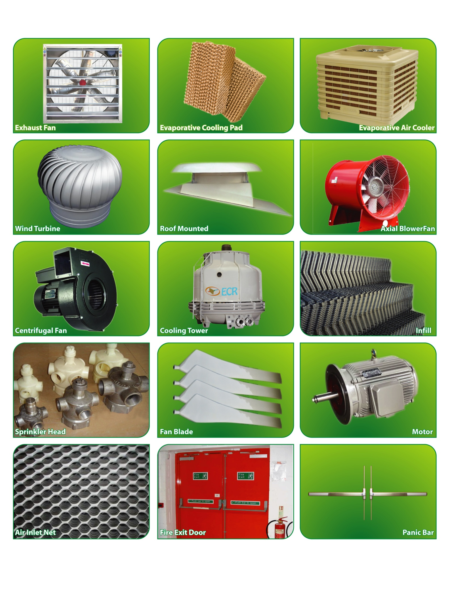

INSTALLATION PICTURE OF OUR PRODUCT

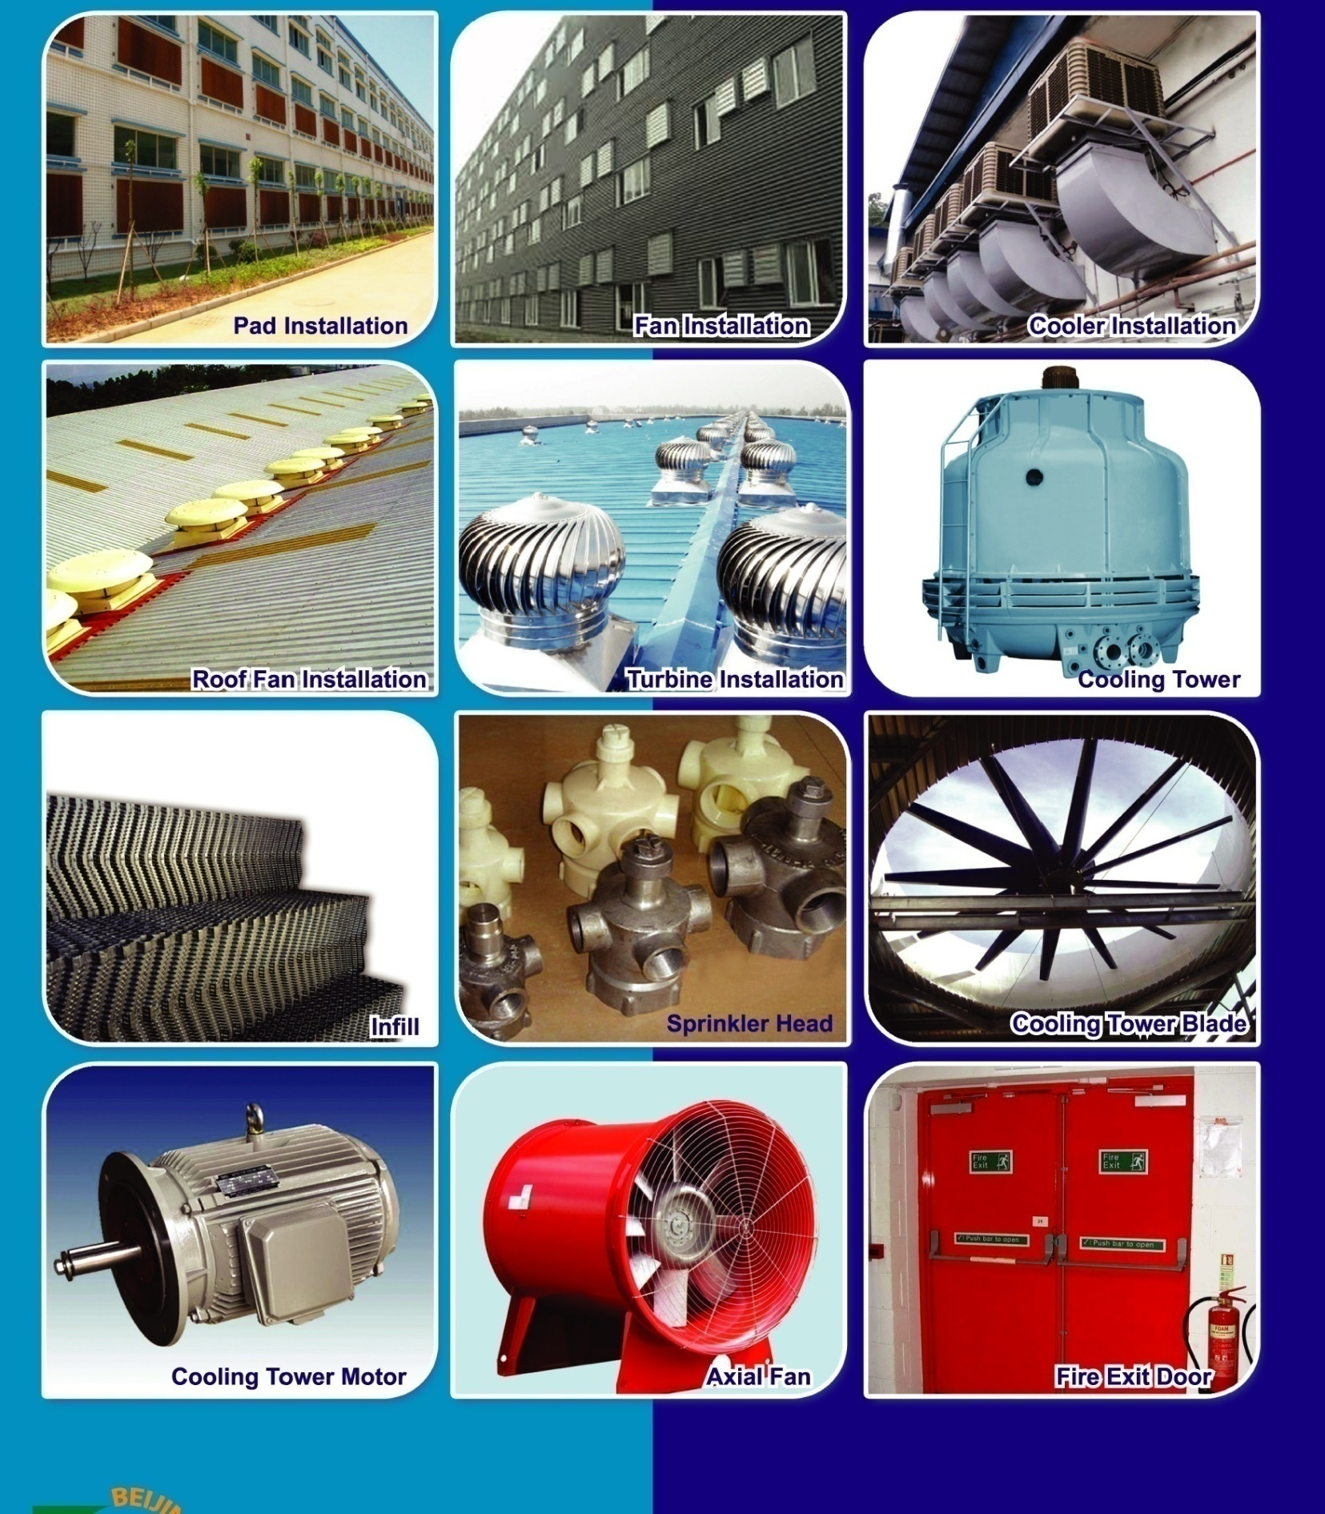

COOLING TOWER AND ITS SPARE PARTS:

We import cooling tower and its spare parts from china. We have iraction team to install and provide sales after supports

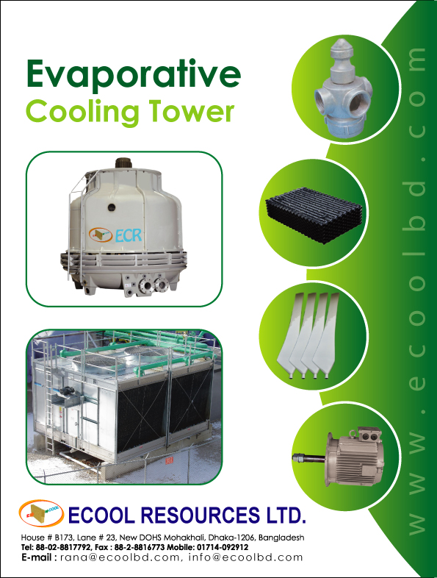

Project implementation equipment and tools description.
Sl. No | Equipments & Tools Description | Unit | Qty | Remarks
a | Measuring Tools
1 | Varnier calipers | Nos | 2
2 | Measurement Tape (Different Type) | Nos | 20
3 | Slide Calipers | Nos | 2
4 | Compus (Different Size) | Nos | 15
5 | Scale (Different Size) | Nos | 10
b | Mechanical working Tools
2 | Arc Welding Machine | Nos | 20
3 | DC Welding Machine (Heavy Duty) | Nos | 20
4 | DC Welding Machine (Light Duty) | Nos | 15
5 | Tig Welding Machine | Nos | 20
7 | Hi Speed Cutter Machine | Nos | 3
8 | Grinding M/C 7" | Nos | 5
9 | Grinding M/C 4" | Nos | 3
10 | Vertical Drill Machine | Nos | 5
11 | Iron Drill Machine (Different Size) | Nos | 4
Sl. No | Equipments & Tools Description | Unit | Qty | Remarks
12 | Hammer Drill Machine (Different Size) | Nos | 5
13 | Baby Drill Machine | Nos | 10
14 | Gas Cutter set | Nos | 20
15 | Adjustable Wrange (Different Size) | Set | 10
16 | Pipe Warence (Different Size) | Set | 12
17 | Chain Ton (Different Size) | Nos | 8
18 | Combination Set (Different Size) | Nos | 10
19 | Torque Wrench (Different Size) | Nos | 12
20 | Box Wrench (Heavy Duty) | Nos | 10
21 | Spanner (Different Size) | Set | 15
22 | Pliers (Different Size) | Nos | 10
23 | Screw Driver (Different Size) | Set | 15
24 | Thread Cutting Machine (Power) | Nos | 4
25 | Thread Cutting Machine (Manual) | Nos | 5
26 | Pipe Cutter (Different Size) | Nos | 12
27 | Pipe vice (Different Size) | Nos | 8
28 | Ball Pin Hammer (0.5Lb to 3Lb) | Nos | 15
29 | Hammer (Different Size) | Nos | 12
30 | Chisel (Different Size) | Nos | 10
31 | Extension Board line | Nos | 5
32 | Collar Bending Machine | Nos | 3
33 | Grip Vice (Different Size) | Nos | 5
34 | Allen key sets (Different size) | Nos | 14
35 | Hole Saw (Different Size) | Nos | 10
36 | Wooden Saw (Different Size) | Nos | 5
37 | Scissors (Different Size) | Nos | 35
38 | Sheet Bending Machine | Nos | 3
39 | Rolling Machine | Nos | 2
40 | Group Machine | Nos | 5
41 | T- Support | Nos | 18
42 | Chipping Hammer |  | 10
E | Safety Equipment
1 | Safety Helmate | Nos | 50
2 | Safety Belt | Nos | 30
3 | Safety Shoe & Glass | Nos | 50
4 | Fire Extinguisher (CO2, A, B, C) | Set | 5

Influential client list
- Textile and garments

- Ha-meem Group  - TM Textile  - Dekko Group  - Knit asia  - Palmal Group of Ind.  - Dishari apparel  - Lenny Fashion  - Fashion city  - Apex  - Birds Group  - Aba Group  - Liz Fashion  - Alima textile  - Agi  - Mascom  - Transcom  - Total Fashion  - Pacific jeans  - Squire Group  - Mahamud Group  Pharmaceuticals  - Globe pharmaceuticals  - Incepta pharmaceutical  - Opsonin pharmaceutical  - Sk+F  - Squire pharmaceutical  - Beximco Ltd. | - Medlar group  - Delta group  - Group group  - Mab group  - Masco  - Viyellatex  - Fashion steps  - Nahid cotton  - Islam group  - Habitus fashion  - Redesha textile  - Abir Fashion  - Otobi  - Nasssa group  - Standard group  - GMS  - Gazi tank and tyre  - Hop lun  - Noman Group

CONTENTS

OVER VIEW
GENERAL INFORMATION OF THE ORGANIZATION
QUALITY STATEMENT
FLOW OF MANAGEMENT
OUR TECHNICAL EXPERTS
SERVICES WE OFFER:
- MECHANICAL ENGINEERING SUPPORT AND SERVICES
- ELECTRICAL ENGINEERING SUPPORT AND SERVICES
- PROJECT IMPLEMENTATION ORGANOGRAM FOR ME. WORK.
- PROJECT IMPLEMENTATION ORGANOGRAM FOR EEE.WORK
- EQUIPMENT AND TOOLS LIST
- PROJECT IMPLEMENTATION MANPOWER LIST
OUR SIGNIFICANT CLIENTS
OUR COMMITTEMENT TO YOUR SATISFACTION

